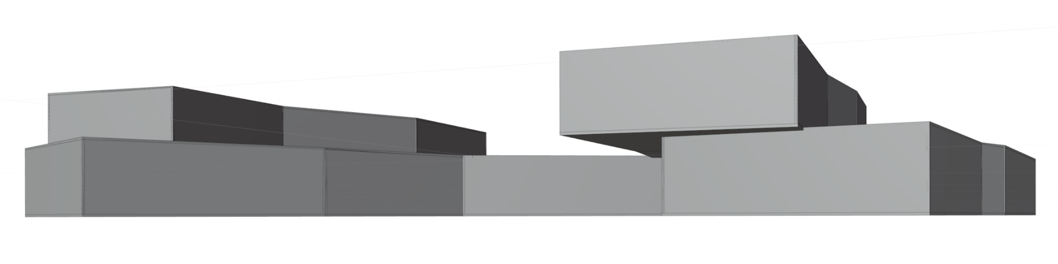

Parametric Space

Jashua Luna

**Delocalization, Hubs and Bridges**

An idea exists beyond any attempts to describe it. The collective agreement of observers becomes the idea.

______________________________________________________________________________

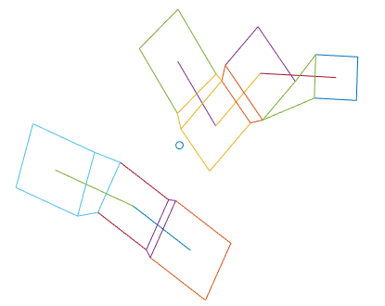

The spatial expression of an idea can be represented by a group of connected hubs. Each hub is a different aspect, and some are connected. Hubs were modelled as circles with random radii. They were spaced such that there was no overlap, and each hub was connected to its nearest neighbor. To unify the hubs as an expression of the collective, they were converted to rectangles (with the same area as the circle which formed it) and oriented towards the nearest hub. A bridge connects each hub to its nearest neighbor, corner to corner. The center of the cluster was calculated as the centroid of the hubs.

The process structures random data into some determined pattern. Accordingly, it can be repeated for an arbitrary number of hubs and levels. A 3d virtualization was created from bridge-hub data. The pattern which structures these hubs relates to proximity to neighbors. Future pattens may include more factors and be more indeterminate than the one herein explored.

**__________________________________________________________________**